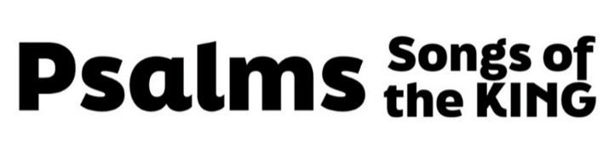
“A Cry In The Dark”
(Psalm 89, pew Bible page 495)

- The Covenant (vv. 1-37)

- God is faithful. (vv. 1-4)

- God is immeasurably powerful. (vv. 5-18)

- God has promised a King for His people. (vv. 19-37)

- The Crisis (vv. 38-51)

- The hopelessness is real. (vv. 38-45)

- The questions are unavoidable. (vv. 46-51)

- How long until You rescue us?

- How does death not win?

- Who can deliver us?

- Where is Your love?

- The Confidence (v. 52)

- The Christ (Luke 1:32-33)

