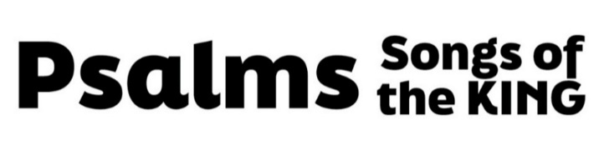
“The King, The Bride, And His Wedding”
(Psalm 45, pew Bible page 471)

- The Context

- The Psalm

- Structure

- Prophetic content

- Inspiration

- The Story (vv. 1-2)

- A real historical king

- A real historical bride

- A prophecy about the King of Kings who has made us His bride

- Hebrews 1:1, 8-9

- The King (vv. 2-9)

- Great (vv. 1-5)

- Divine (vv. 6-9)

- God (vv. 6-7)

- Messiah (v. 7)

- Hebrews 2:14-18

- Gracious Heavenly King (v. 8)

- Hebrews 4:16

- Worshipped (vv. 8-9)

- The Bride (vv. 10-15)

- Foreign

- Ephesians 2:13

- Humble

- Redeemed

- The King’s Wedding (vv. 16-17)

- Relationship

- Worship

- Hebrews 10:22-23

- Eternity

