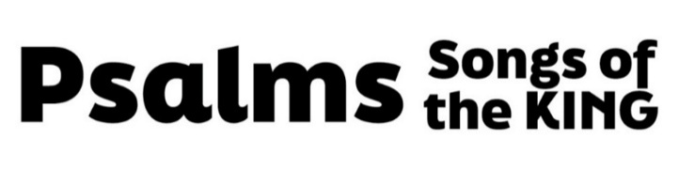
“Our Coming King”
(Psalm 110, pew Bible page 509)

- Jesus’ Rule (vv. 1-3)

- Philippians 2:9-11

- Place

- Mark 16:19

- Acts 2:33-35

- Power

- Psalm 147:5

- Colossians 1:16-17

- Ephesians 1:20-21

- 1 Timothy 6:15

- People

- Jesus’ Role (vv. 4-7)

- Priest

- Hebrews 10:11-16

- 1 Timothy 2:5

- Hebrews 4:14-16

- Hebrews 1:3

- 1 John 2:1

- King: Coming Judge

- Revelation 19:11-15

- Romans 8:34

